Homework 1

# Connection

Project name: EXAMPLE-PROJECT ADTA 5550

Project ID: temporal-tensor-279517

# Part 1: Set up deep learning VM in GCP

## Requirement 1.1

**Write a brief report to summarize the major steps of setting up the remote server**

Using the google cloud platform, anyone can create a virtual machine. Using the example project I created earlier, I followed the steps of this [document](https://drive.google.com/file/d/1YGUL8JZk8wCab_yZuKRgO2k2weKWBg59/view) and set up a virtual machine. It’s important to note that cost savings is best with the e2-standard-x CPU selection. When the virtual machine instance is not being used, it’s important to stop the VM to avoid unnecessary charges.

**Capture the screenshot that shows the critical information of the newly created remote instance**

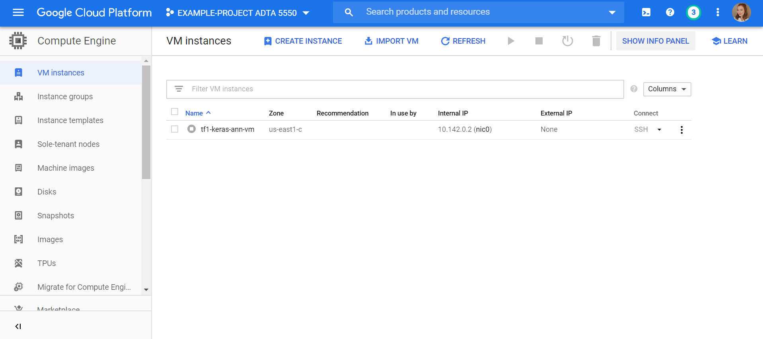

## Requirement 1.2

**Write a brief report to summarize the major steps of installing the GCLOUD SDK.**

I followed the steps of this [document](https://drive.google.com/file/d/1pjvJaXTbbhSUlgJC2_j65QA2me0fLwCy/view) and set up a terminal instance for google cloud. I signed in and used the project I had made previously.

**Capture the screenshot that shows the tool has been successfully installed.**

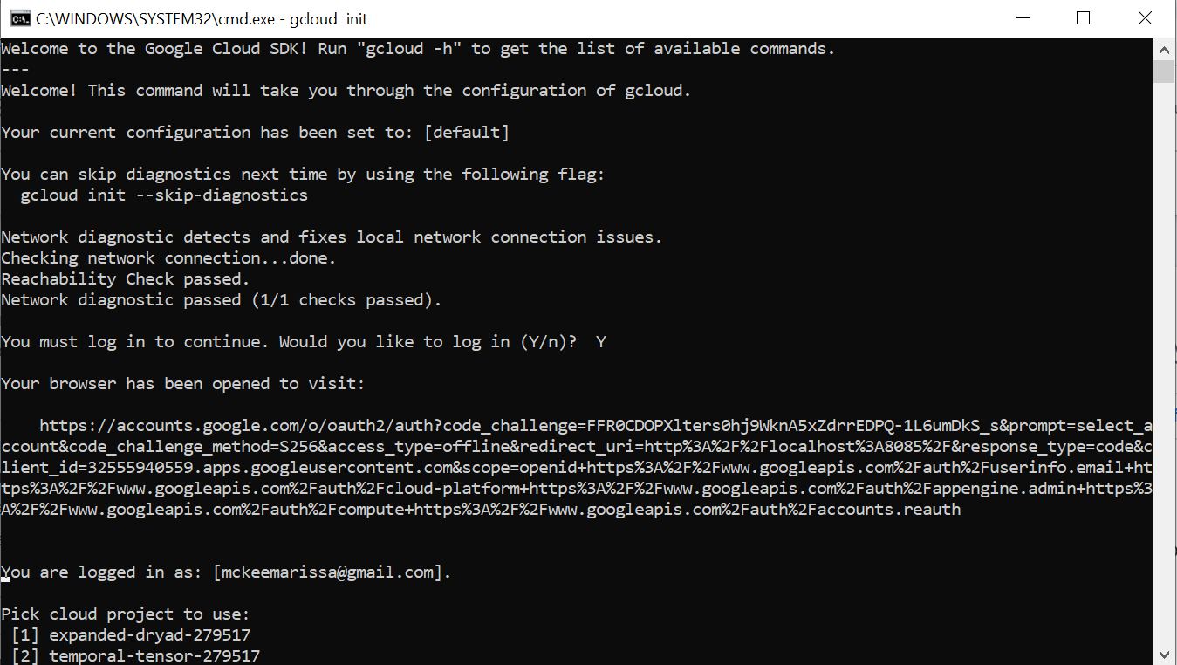

# Part 2: Connect explore remote VM using SSH

## Question 2.1

**Based on the lectures, open an SSH connection from the local computer to the remote VM.**

Commands:

Authorize login to the google account

>> gcloud auth login

Set up the config file and compute engine for google cloud

>> gcloud compute config-ssh

SSH into the VM instance set up earlier using the SSH command in the GC console

>> gcloud beta compute ssh --zone "us-east1-c" "tf1-keras-ann-vm" --project "temporal-tensor-279517"

## Question 2.2

**Using the basic Linux command lines to explore the contents of the home directory**

Using basic Linux commands, examples down below, I explored the terminal directory. Because the directory is new, it is empty.

>> Pwd

/home/mckee

>> Whoami

mckee

## Question 2.3

**Create a new sub-folder named “JPTR_NTBK” under the home directory**

>> mkdir JPTR_NTBK



## Question 2.4

**Change the current directory to the newly created folder**

>> cd JPTR_NTBK/

## Requirement 2

**Write a brief report to describe the major activities the student has finished in PART II**

I used the SSH key to log into my google cloud virtual machine instance where I performed very simple Linux commands. The JPTR_NTBK was created for python projects in the future.

# Part 3: Start and Connect to Jupyter Notebook in remote VM

## Question 3.1

**Based on the lectures, start the Jupyter Notebook server in the remote virtual machine**

Terminal 1 command:

>> jupyter notebook --port=8888

Terminal 2 command:

>> gcloud beta compute ssh --zone "us-east1-c" "tf1-keras-ann-vm" --project "temporal-tensor-279517" -- -L 8000:localhost:8888

Go to <http://localhost:8000> in a browser and insert the token from terminal 1

Using the [instructions](https://drive.google.com/file/d/1expmCL_JEcOfN5aDNK_9LXU6XvFXHjI7/view) provided, I followed the steps to start a Jupyter Notebook server from the remote virtual machine.

## Question 3.2

**Connect to the Jupyter Notebook server in the remote virtual machine**

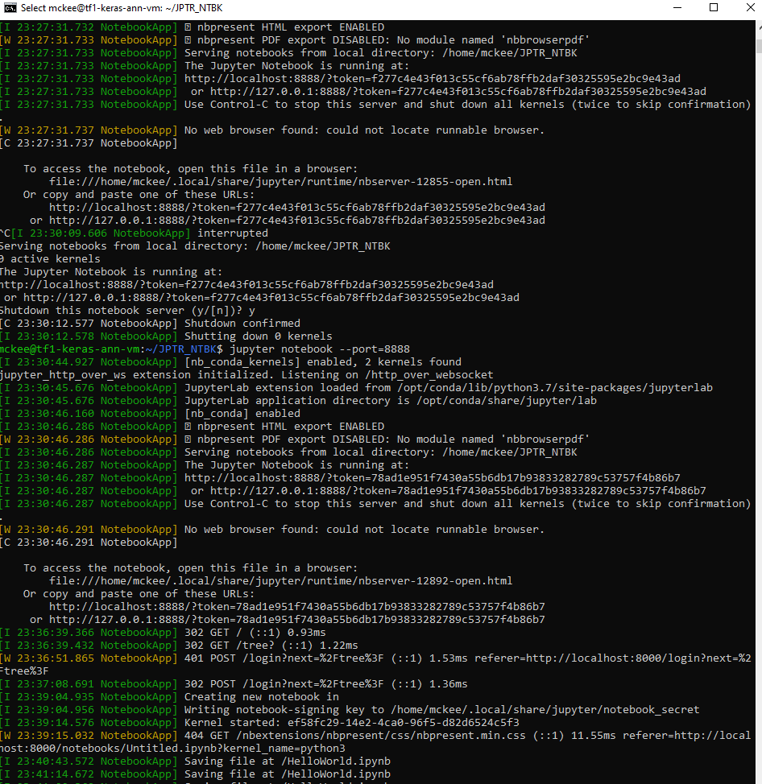

## Question 3.3

**Run Jupyter Notebook in a local browser**

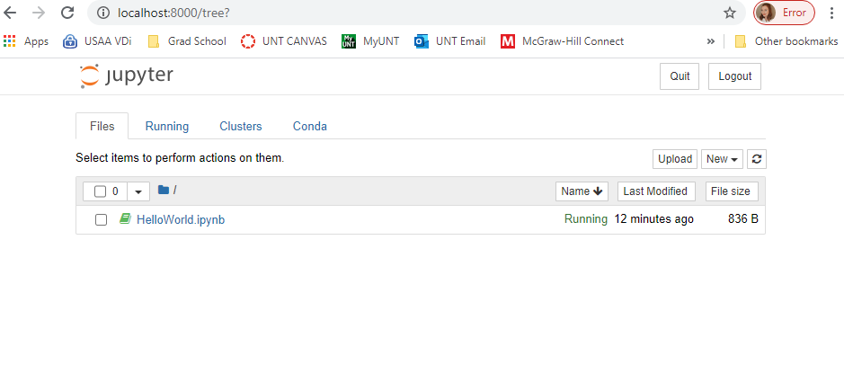

## Requirement 3

**Write a brief report to explain the steps the student has done to start, connect, and use Jupyter Notebook that runs in the remote virtual machine.**

Using the instructions provided, I opened a google cloud terminal and ran a command to initialize a Jupyter Notebook session. A token is issued for the notebook server when this command is run. I save the token in a text file for later. I opened a second google cloud terminal and SSHed into the jupyter port where a terminal window opened up. Finally, to connect the jupyter Notebook instance to the virtual machine, I opened the local host URL into a browser and connected with the token saved from earlier.

# Part 4: Write simple python code in Jupyter Notebook in remote VM

## Question 4.1

**Create a vector (1D array) of size 20. All the elements are initialized with 0 (zero) except for the 8th element that is set with the value 8.**

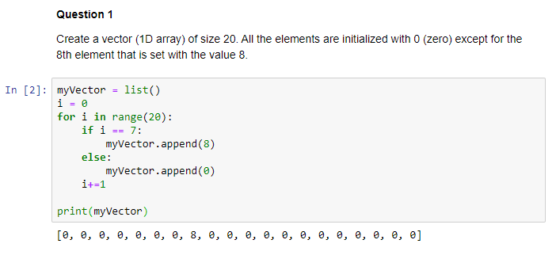

## Question 4.2

**Create a vector of size 16 with random values ranging from 0 to 63, print the vector, then sort it and print the vector again.**

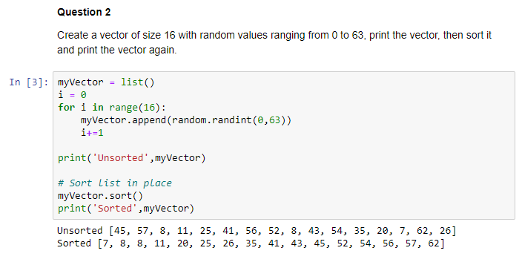

## Question 4.3

**Create a 5x5 matrix with values ranging from 0 to 24.**

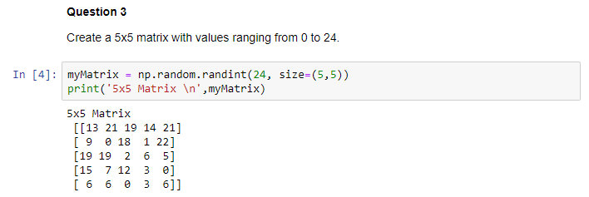

## Question 4.4

**Create an 8x8 array with random values, then find the min and max values stored in this matrix.**

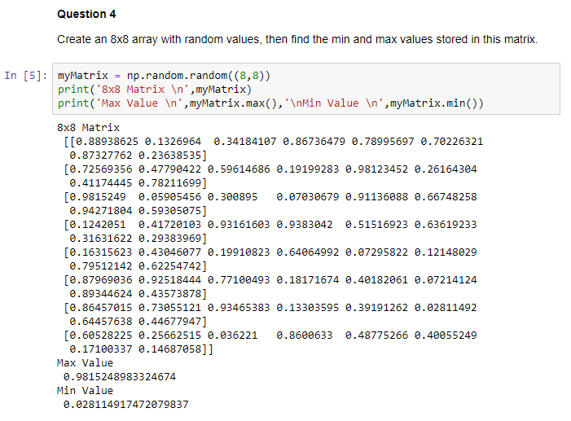

## Question 4.5

**Create a vector of size 32 that is initialized with random values inside the range (0, 99) and then find the mean of all the initial values.**

